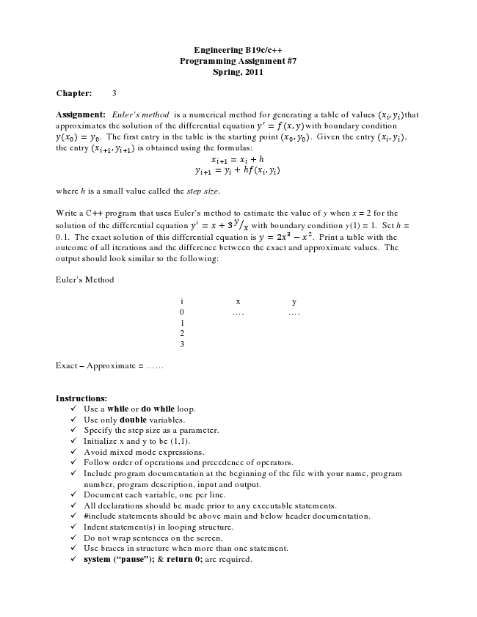

**Engineering B19c/c++ Programming Assignment #7 Spring, 2011**

**Chapter: 3**

Assignment: Euler’s method is a numerical method for generating a table of values , that approximates the solution of the differential equation = , with boundary condition

= . The first entry in the table is the starting point , . Given the entry , , the entry , is obtained using the formulas:

= + h = + h ,

where h is a small value called the step size.

Write a C++ program that uses Euler’s method to estimate the value of y when x = 2 for the solution of the differential equation = +3 with boundary condition y(1) = 1. Set h = 0.1. The exact solution of this differential equation is = 2 − . Print a table with the outcome of all iterations and the difference between the exact and approximate values. The output should look similar to the following:

Euler’s Method

i x y 0 .... .... 1 2 3

Exact – Approximate = ......

**Instructions:**

✓ Use a while or do while loop. ✓ Use only double variables. ✓ Specify the step size as a parameter. ✓ Initialize x and y to be (1,1). ✓ Avoid mixed mode expressions. ✓ Follow order of operations and precedence of operators. ✓ Include program documentation at the beginning of the file with your name, program

number, program description, input and output. ✓ Document each variable, one per line. ✓ All declarations should be made prior to any executable statements. ✓ #include statements should be above main and below header documentation. ✓ Indent statement(s) in looping structure. ✓ Do not wrap sentences on the screen. ✓ Use braces in structure when more than one statement. ✓ system (“pause”); & return 0; are required.